Keywords: Inertial Support, Synthetic Inertia, Grid Integration of Renewable Energy Systems
Inertial Support Capability of Wind Turbines for Varying Wind Speeds
E. Duymaz, O. Keysan

One of the most important problems of high renewable energy penetration is the decrease in effective grid inertia. Most variable speed wind turbine drive-trains decouple the turbine’s rotational speed from the grid frequency. Even though this implementation brings the maximum aerodynamic efficiency, it also decouples the inertia existing in the wind turbine from grid. However, it is possible to construct a virtual relation between the turbine speed and grid frequency that is called ‘synthetic inertia’ or ‘virtual inertia’, which temporarily increases the turbine active power when the grid frequency decreases. The source of the active power is the stored kinetic energy in the turbine blades.
In this paper, the inertial support in a wind turbine with full-scale power electronics is implemented on the Machine Side Converter (MSC) which adjusts the generator torque according to the MPPT algorithms in the normal operation. The maximum value of a possible inertial support power is investigated by considering the effects of the wind speed and the converter rating. The available active power increase is shown in the Fig. 1.a. for the wind turbine GE2.75-103 which is a PMSG wind turbine with a power rating of 2.75MW. Since the converter power rating is 10% above the active power, it is possible to increase active power by 10% in wind speeds above 10.5m/s. Nonetheless, the active power can be increased more than 45% in wind speeds between 5m/s and 8m/s. Therefore, lower wind speeds have higher potential and capacity for the inertial support capability. The higher active power increase contributes better for the frequency disturbances which is caused by the unbalance between supply and demand.
In order to evaluate the contribution of the different wind speeds, a wind speed measurement data taken from a wind farm in Balıkesir is utilized. When the probability density function of the measurement is multiplied with the available active power increase, the net contribution for the different wind speeds is found and shown in Fig. 1.b. Since the turbine in cut-off in wind speeds below 3m/s, no inertial contribution can be obtained. Lower contribution is obtained in high wind speeds due to the lower probability and limited increase capability. However, the main contribution is yielded especially wind speeds between 4m/s and 9m/s. The average inertial contribution of the wind turbine is found as 30% by integrating the area below Fig.1.b. The study also investigates the effect of the stored kinetic energy on the inertial support. By utilizing the converter capability and the stored kinetic energy, the limits of the inertial support will be investigated. Moreover, the sustainability of the inertial support will be studied by restricting the decrease on the generator speed. The result of the study will reveal the performance comparison of different wind speeds on the inertial support.

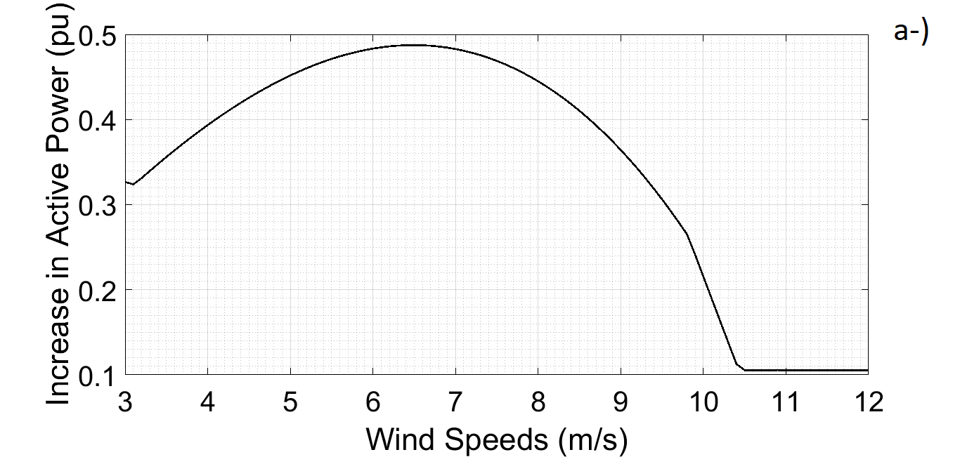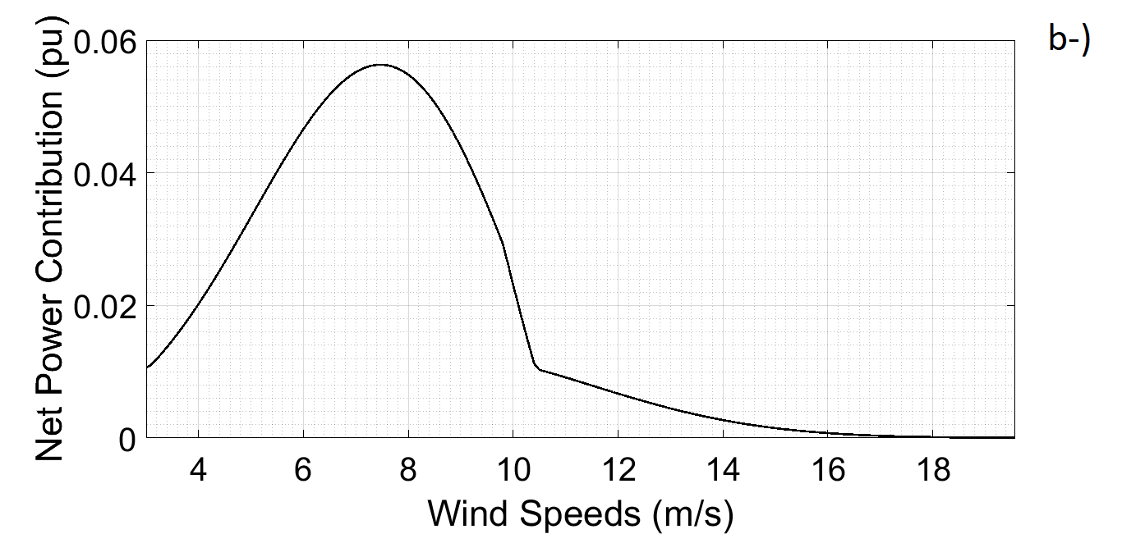

Figure 1: (a) Available increase in the active power (b) Net contribution of different wind speeds
_______________________________________________________________________________________

[a] Dep. Electrical Engineering, Middle East Technical University, Dumlupınar Bulvarı No:1, Ankara, Turkey

